**CHAPTER I – INTRODUCTION**

One of the advantages of having the Salon Finder and management Booking System is to help Salon business can accept bookings 24/7, so the customer doesn’t have to wait until the next day. It also helps the customer to find other suitable salons. The objective of this application is to locate the nearest Salons along with the city and to make appointments right away.

There are three intended users: First, The Users/Customers who can book and inquire to any Salons. Second would be the Salon owners, who will manage all the admin management app. Third, the Super Admin can have full access to the database side and can handle all the activation to any application users.The software developer handles the Super Administrator, we allows the clients to choose from standard domains like .com, .net, .org, .info, .biz and etc, to help simplify their address for our customers. Also, We will set up the booking system. Each app has same functionality but with a unique web design.

It also saves time since app users can process all requests by statuses. It is a perfect solution for all users to make appointments on the go as they can install the app on their android Phones. It can increase the efficiency of all operations. It reduces the amount of administrative work that Salons owners might have to adjust staff responsibilities. This application is very user friendly and will become a best friend for all beauty lovers out there. So, now we have heard how technology helps us to bring our life so instant.

**STATEMENT OF THE PROBLEM**

Some service-based Salon businesses have implemented online applications to increase the revenues on their business that will automate the manual processing procedures. Since we are indulging with the technologies, so we want some changes that solve the problems with so many beauty salons out there today. One of the main problems that Salon owners faced is how to gain more customers or getting new clients. The best way to have more clients is to have an online Salon booking website that has been optimized for Google and other major search engines. This application can find any Salons, so If someone searches for the nearest Salon, so all registered Salon is going to be on the list. Many people are interested in beauty, beauty salons but some of us may not have the opportunity to go to the salon to make an appointment. Second, time is important for every client, they want instant so if they want to ask about time and date availability then this application is the best to serve them and give gratification to every client who wants to make appointments on the go. Third, is the paper works or the manual procedure of keeping the records. This application has designed to help Salons automate the data processing and without any hassle, because this is not just a user friendly but also an on the go app. The application is accessible for any latest version of Android Phones.

**PURPOSE/OBJECTIVE OF THE STUDY**

* To develop an application that can help Salon Businesses to have fast data processing and achieve more customers as their salon will be visible on the search engine.
* To provide a solution to the problem in searching available Salons and get direction via Google Map.
* To help Users make an appointment on the go as they can install the app on their android Phones.
* To help the customer to find a beauty salon that can satisfy them, as this application will show all the registered salons together with all necessary details.
* To help speed up the process of beauty salon.
* To automated the manual reservation of salon.
* To standardized the reservation system with the customers.
* To reduce the amount of time to and effort consume.
* Provide user account and password for security of stored files.
* To reduce their expenses in making reservation.

**SIGNIFICANCE OF THE STUDY**

# A Salon Finder & management booking system can save you time, money, and energy. So these studies help us arrive at the ideal solution for salon business owners. How the system help salons improve and grow? Every Salon has different answers. Some may have difficulties engaging and retaining customers. Others have been struggled with keeping the clients, since they may not return because appointments never start on time as stylists spend too long with previous customers. So, implementing software for Salons can be an important tool to cope with the challenges. As the product features to solve the main problem on every Salon like online booking, find near Salons and Manage the business on the go as they can access the app through the latest version of android phones.

 Implementing the software is a lifetime investment for every Salon Business owners as this software can help to get more customers through (SEO) Search engine optimization process that will boost the accountability and consistency of the customers to get into your Salon Website. Also, It is the most hassle-free app, designed for all registered users to manage the system anytime by themselves as long as they have an internet connection along the way.

**SCOPE AND LIMITATIONS**

The scope and limitations of this study rely upon the functionalities of this application. Users must have an internet connection so they can use the app. There are three intended users: First, The Users/Customers who can book and inquire to any Salons. The second would be the Salon owners, who manage all the admin management app. Third, the Super Admin can have full access to the database side and can handle all the activation to any application user. In this case, these salons can be visible on the app search engine.

**Scope**

**Super Administrator**

* Super Admin has a login account.
* Super Admin can update the information of the registered Salon owners.
* Super Admin can update and delete Salons.
* Super Admin can activate/deactivate application users.
* Super Admin can view all pending request of the Salon owners.
* Super Admin can be able to logout the account.

**Community (User)**

**Registered Salon App Users (Owners)**

* Admin User has a login account.
* Admin User’s Website will have the Search engine optimization: the process of making a site better for search engines.
* Admin User can view all status of booking request.
* Admin User can cancel pending booking request if customer confirmed the cancellation.
* Admin User can approve booking request.
* Admin User can add and delete services by category.
* Admin User can Archived booking request that has been approved.
* Admin User can be able to logout.

**Non-Registered Users**

* Non-Registered User can view the Salon direction, time availability and some information.
* Non-Registered User can search suitable Salons.
* Non-Registered User can make appointments per day.
* Non-Registered User can view and book services.

**Limitation**

The limitations of this application are:

* Not applicable in iOS
* Community account users can’t change anything on the app because of the reliability/ security issues.
* Online payments are not acceptable.
* This application can’t be access offline.

**CONCEPTUAL FRAMEWORK**

The process flow of the system is to demonstrate how it works to all users. It conceptualized the importance of having an online salon application. Nowadays, People prefer to market products and services online. In this case, we have introduced this software for all Salon owners as this helps all Salon businesses to be known, to improve and grow their Salon. This app can help Salon owners approved all customer's requests, manage all bookings and services on the go. Additionally, All users can have full access to mobile and web apps.

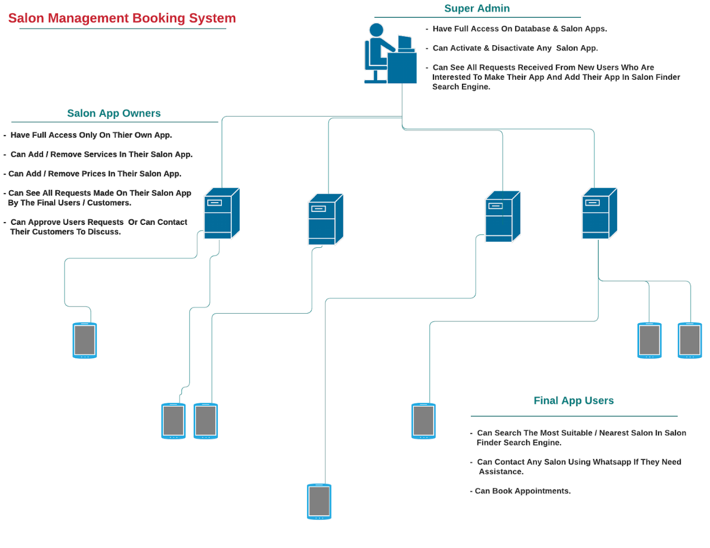

*Figure 1. Show the concept of Salon Application*

Literature Review

This is a time of world-wide competition; all of the worlds are competing with each other’s using absolute and advanced technological features. The most common example of innovation is in information technology and communication.

Advancements of software and using the internet to maintain and monitor their e-commerce. In the application of the informative systems, the salon reservation system is one of the used systems.

The literature review deals with the many topics and the researches that would help to understand Salon Finder and Salon Booking and Management System. The main objective of this literature review is to analyze the related work to this project also mechanisms used in previous studies. The following proposed system aims to develop a simple website for facilitating the reservation process at the salon. The system provides an easy way for searching nearest Salon, make an appointment and check available days, inserting the customer's information, getting details when need information about a specific customer, also making a reservation for services online. The management system can be accessed through android Phones, that users can add, update, delete the salon services. Enables the admin user to approve, cancel, and archive all the bookings information.

This chapter reviews the existing system and techniques related to Salon Finder and Salon Booking and Management System. Also deals with the topics and the researches that would help to understand and use of Reservation System for beauty salon. Without an online booking system, you will have to rely on phone calls and go to the salon only to make reservations. Clearly, an online booking system and Salon finder is necessary and required nowadays as we still defend ourselves to prevent the spread of the Pandemic Covid-19 in 2020, that is why we would like to point out the benefits every good online booking system should bring you as it works 24/7.

A Salon Finder and Salon Booking and Management System works all the time. This gives freedom to potential customers to book services anytime they want and maximizes your sales because you are not limited to your working hours. Studies show that a 24/7 online reservation system greatly increases the number of bookings.

It saves a lot of time and effort.

A Salon Finder and Salon Booking and Management System makes salon staff more efficient because they won’t be tied to a phone waiting for guest calls. Most of the time employees will get new reservations online and they will have more free time to do other things instead of playing phone tag.

2.2 Booking system or Reservation system In 1946, American Airlines installed the first automated booking system, the experimental electromechanical Reservoir. A newer machine with temporary storage based on a magnetic drum, the Magnetron Reservoir, soon followed. This system proved successful, and was soon being used by several airlines, as well as Sheraton Hotels and Goodyear for inventory control. It was seriously hampered by the need for local human operators to do the actual lookups; ticketing agents would have to call a booking office, whose operators would direct a small team operating the Reservoir and then read the results over the telephone. There was no way for agents to directly query the system  
(source: https://en.wikipedia.org/wiki/Computer_reservation_system#History )  
Computer reservation system  (CRS) is a computerized system used to store and retrieve information and conduct transactions related to air travel, hotels, car rental, or other activities. Originally designed and operated by airlines, CRSs were later extended for the use of travel agencies. Global distribution systems (GDS) book and sell tickets for multiple airlines. Most airlines have outsourced their CRSs to GDS companies which also enable consumer access through Internet gateways. Modern GDS’s typically allow users to book hotel rooms, rental cars, airline tickets as well as other activities and tours. They also provide access to railway reservations and bus reservations in some markets, although these are not always integrated with the main system. These are also used to relay computerized information for users in the hotel industry, making reservation and ensuring that the hotel is not overbooked.

In 1976 defines computers based information systems as structured systems that rely on computer hardware and software technology to collect, process, and store and distribute information. Information systems are employed to support decision making and control in business. Information systems can also be used to analyse problems, visualize complex subjects, and create new products. Input, processing and output are the three activities in an information system that produces the information a business needs.  
2.3 Beauty Salon

Beauty salons have proven to be a recession-proof industry across United States. Although sales had declined from 2008 highs due to the Great Recession, they remain robust with long term positive forecast. Even though during recessions, consumers tend to be more price conscious, spending continues to go increase. With rising per capita incomes across the United States since 2015, beauty salons are booming with the industry generating $56.2 billion in the United States.

Hair care is the largest segment with 86,000 locations. Skin care is expected to have revenue of almost $11 billion by 2018. This growth is being driven in part by a generally increasing awareness of the importance of skin care among American woman, but also specifically due to an increase in the market for men. The market is distributed widely across America, with a concentration in the Northeast and Midwest. There is also a growing trend in boutique salons popping up and leveraging online marketing to gain customers and compete with the franchise chains. The US Labour Department estimates employment in the United States will increase 20% between 2008–2014, with greatest employment growth from skin care specialists.  
(Source: https://en.wikipedia.org/wiki/Beauty_salon#Industry )

**CHAPTER II – METHODS**

This chapter will define the methods used in research to conduct the study of the Salon Finder and Booking Management System. The proposed system has gone through the procedures like costing, hardware specification, pre-survey result, post surveys chapter will define the methods used in research to conduct the study of Salon Finder, and Booking Management System. These methods help the researchers to utilize suggestions to develop the system successfully. The researchers conducted quantitative surveys in which the respondent (Salon Customers, Friends, etc.) fill up forms using google form surveys and qualitative surveys, asking the respondent (Salon Owners) verbal questions. The researcher compares the system to the current Salon booking system on the internet. These are the salon booking systems that have been used by developed outside the country.

**Pre-Survey Questions and Result**

1. When a salon is closed, do you prefer to book online?

This part of the survey conclude that 70% of the customer preferred to book online while 20% preferred to book online or walk in and 10% does not want to book online. Above All, Booking online gets the higher percentage since nowadays we need to consider the safety and hassle free services.

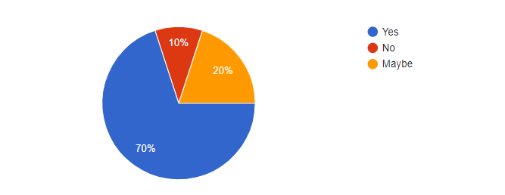

1. Before making a booking, Do you like to check the services offered directly on the website?

This part of the system conclude that 90% of the customer wants to see the price of the services before making an appointment. This is to check if the prices greatly affect the customer’s decision when choosing a Beauty Salon.

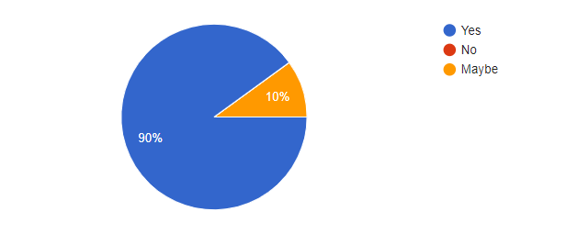

1. Do you want to see first the upcoming deals and promotions before choosing a booking date?

This part of the system conclude that customer wants to know the promotions of the Beauty Salon.

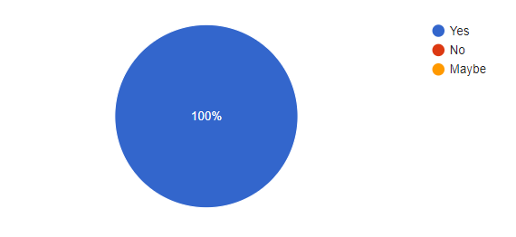

1. Is it helpful for you to display on the website, the reviews & testimonials, before and after pictures of past work before choosing a salon?

This part of the survey stated that 90% of the customer really wants to know the reviews and testimonials before choosing a Beauty Salon.

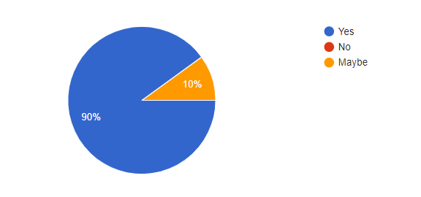

1. Is it helpful for you to include a detailed description of treatments & services displayed on the website?

This part of the survey suggested to include the services description so the customer will have idea about the services offered.

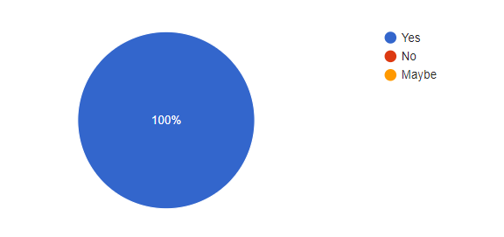

1. Do you also want to know the information on products used or for sale at the salon? This part of the survey concluded that 90% of the customer wants to know the products used in the Salon.

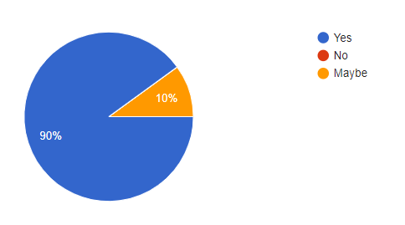

1. Which of these two features are most important to you on the salon/barber/spa website? This part of the survey stated that the products for sale online and having a blog and news about the latest trends are both important for the customer.

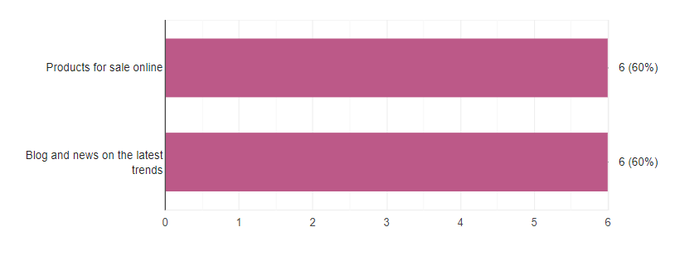

1. This software can help to search available Salons and get directions via Google Map. Do you like the concept of the Software?

This part of the survey concluded that the customer like the concept of searching available salons and will give a specific direction to go to that Beauty Salon.

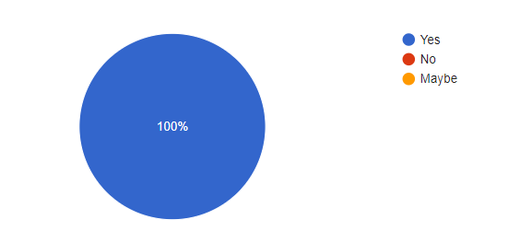

1. 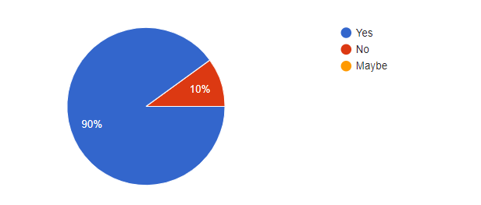Do you like to check other salons on the same website after checking one salon you visited online? This part of the survey stated that out of 100% there was 90% who says that he/she wants a system that can check another salon in just one website.
2. Is it helpful for you to use a website that can find the nearest salon and display the location and prominently displayed the salon opening hours?

This part of the survey stated that having a software that can easily find a nearest salon together with display of the important details before booking is helpful for them.

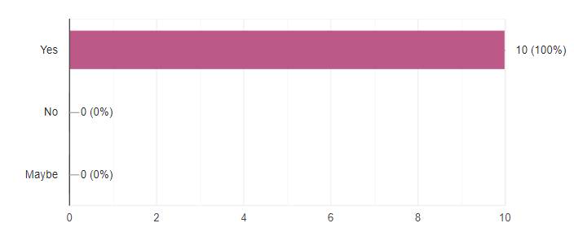

**Pre-Survey Result**

|  |  |  |  |  |
| --- | --- | --- | --- | --- |
| **Questions** | **No. of respondent** | **Percentage** | | |
| 1. When a salon is closed, do you prefer to book online? | 25 | Yes | No | Sometimes |
| 68% | 4% | 28% |

*Table 1. Pre-Survey Result (Q1)*

|  |  |  |  |  |
| --- | --- | --- | --- | --- |
| **Questions** | **No. of respondent** | **Percentage** | | |
| 2. Before making a booking, Do you like to check the services offered directly on the website? | 25 | Yes | No | Maybe |
| 70% | 10% | 20% |

*Table 2. Pre-Survey Result (Q2)*

|  |  |  |  |  |
| --- | --- | --- | --- | --- |
| **Questions** | **No. of respondent** | **Percentage** | | |
| 3.Do you want to see first the upcoming deals and promotions before choosing a booking date? | 25 | Yes | No | Maybe |
| 90% | 10% | N/A |

*Table 3. Pre-Survey Result (Q3)*

|  |  |  |  |  |
| --- | --- | --- | --- | --- |
| **Questions** | **No. of respondent** | **Percentage** | | |
| 4. Is it helpful for you to display on the website, the reviews & testimonials, before and after pictures of past work before choosing a salon? | 25 | Yes | No | Maybe |
| 90% | N/A | 10% |

*Table 4. Pre-Survey Result (Q4)*

|  |  |  |  |  |
| --- | --- | --- | --- | --- |
| **Questions** | **No. of respondent** | **Percentage** | | |
| 5. Is it helpful for you to include a detailed description of treatments & services displayed on the website? | 25 | Yes | No | Maybe |
| 100% | N/A | N/A |

*Table 5. Pre-Survey Result (Q5)*

|  |  |  |  |  |
| --- | --- | --- | --- | --- |
| **Questions** | **No. of respondent** | **Percentage** | | |
| 6. Do you also want to know the information on products used or for sale at the salon? | 25 | Yes | No | Maybe |
| 90% | N/A | 10% |

*Table 6. Pre-Survey Result (Q6)*

|  |  |  |  |
| --- | --- | --- | --- |
| **Questions** | **No. of respondent** | **Percentage** | |
| 7. Do you like to check other salons on the same website after checking one salon you visited online? | 25 | Yes | No |
| 90% | 10% |

*Table 7. Pre-Survey Result (Q7)*

|  |  |  |  |
| --- | --- | --- | --- |
| **Questions** | **No. of respondent** | **Percentage** | |
| 8. Which of these two features are most important to you on the salon/barber/spa website? | 25 | Products for sale online | Blog and news on the latesttrends |
| 60% | 60% |

*Table 8. Pre-Survey Result (Q8)*

|  |  |  |  |  |
| --- | --- | --- | --- | --- |
| **Questions** | **No. of respondent** | **Percentage** | | |
| 9. This software can help to search available Salons and get directions via Google Map. Do you like the concept of the Software? | 25 | Yes | No | Maybe |
| 100% | N/A | N/A |

*Table 9. Pre-Survey Result (Q9)*

|  |  |  |  |  |
| --- | --- | --- | --- | --- |
| **Questions** | **No. of respondent** | **Percentage** | | |
| 10. Is it helpful for you to use a website that can find the nearest salon and display the location and prominently displayed the salon opening hours? | 25 | Yes | No | Maybe |
| 100% | N/A | N/A |

*Table 10. Pre-Survey Result (Q10)*

**Post Survey**

The survey used google form for quantitative respond of the respondent which is the students.

1. How often do you at least go to the salon?

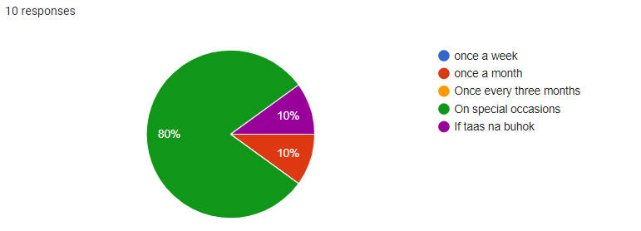

1. Do you make reservations before going to the salon?

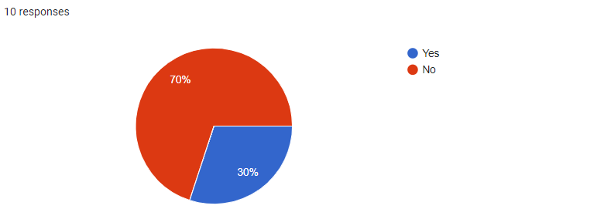

1. What are the most common problems that you face when you go to the salon?

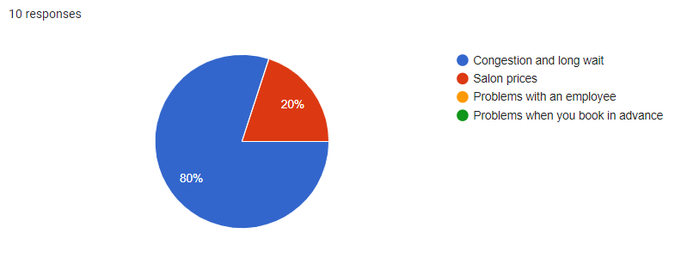

1. .What are the factors that greatly affect your decision when choosing a beauty Salon?

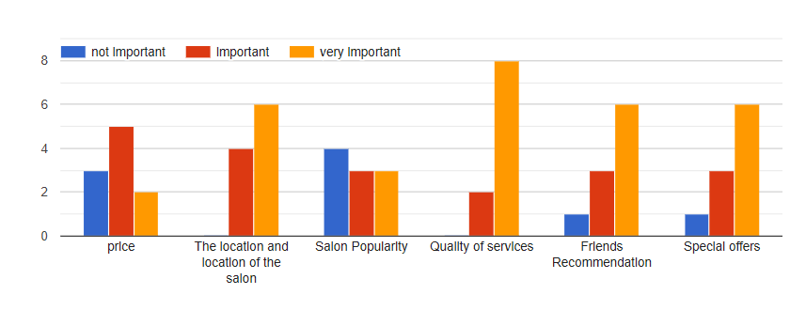

1. What are the ways that you go to search for a beauty salon?

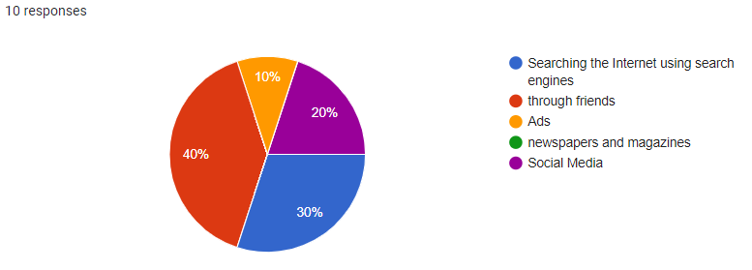

1. Do you prefer to book appointments through the mobile application?

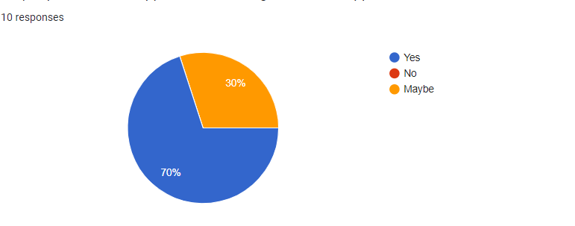

1. Do you want to know all the salons around you and near you and know the services you provide and learn about others' experience?

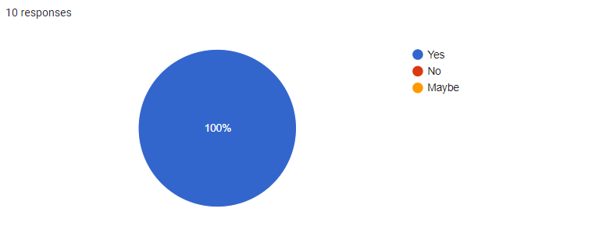

1. What OS do you prefer for the application?

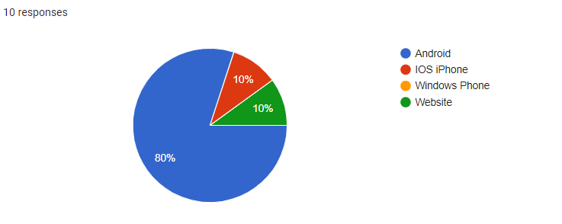

1. Do you have any suggestions on our project?

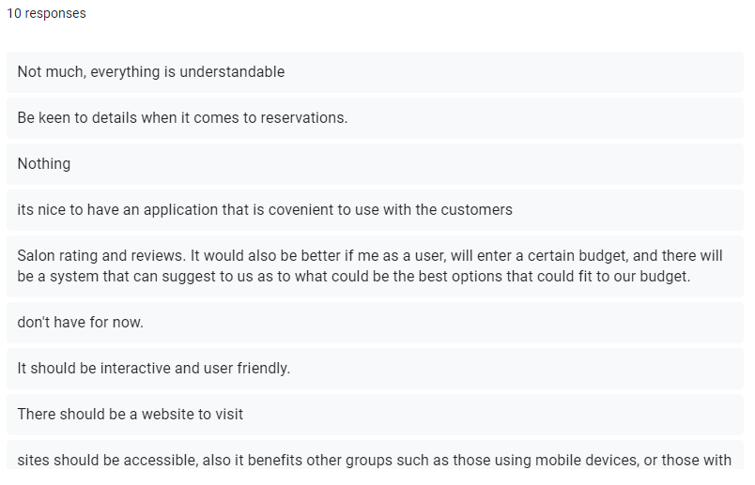

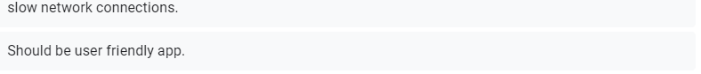

*Figure 18. Comment and suggestion of the system.*

**Post-Survey Result**

|  |  |  |  |  |  |  |
| --- | --- | --- | --- | --- | --- | --- |
| **Questions** | **No. of respondent** | **Percentage** | | | | |
| 1.How often do you at least go to the salon? | 10 | once a week | once a month | Once every three months | On special occasions | Other: |
| 0(0%) | 0(0%) | 1(10%) | 8(80%) | 1(10%) |

*Table 11. Post- Survey Result (Q1)*

|  |  |  |  |
| --- | --- | --- | --- |
| **Questions** | **No. of respondent** | **Percentage** | |
| 2. Do you make reservations before going to the salon? | 10 | Yes | No |
| 3(30%) | 7(70%) |

*TTable 12. Post- Survey Result (Q2)*

|  |  |  |  |  |  |
| --- | --- | --- | --- | --- | --- |
| **Questions** | **No. of respondent** | **Percentage** | | | |
| 3.What are the most common problems that you face when you go to the salon? | 10 | Congestion and long wait | Salon prices | Problems with an employee | Problems when you book in advance |
| 8(80%) | 2(20%) | 0(0%) | 0(0%) |

*TaTable 13. Post- Survey Result (Q3)*

|  |  |  |  |  |  |
| --- | --- | --- | --- | --- | --- |
| **Questions** | **No. of respondent** | **Salon Factors** | **Percentage** | | |
| 2. What are the ways that you go to search for a beauty salon? | 10 |  | Important | not important | Very important |
| price | 5(50%) | 3(30%) | 2(20%) |
| The location and location of the salon | 4(40%) | 0(0%) | 6(60%) |
| Salon Popularity | 3(30%) | 4(40%) | 3(30%) |
| Quality of services | 2(20%) | 0(0%) | 8(80%) |
| Special offers | 3(30%) | 1(10%) | 6(60%) |

*Table 14. Post- Survey Result (Q4)*

|  |  |  |  |  |  |  |
| --- | --- | --- | --- | --- | --- | --- |
| **Questions** | **No. of respondent** | **Percentage** | | | | |
| 2. What are the ways that you go to search for a beauty salon? | 10 | Searching the Internet using search engines | through friends | Ads | newspapers and magazines | Social Media |
| 3(30%) | 4(40%) | 1(10%) | 0(0%) | 2(20%) |

*Table 15. Post- Survey Result (Q5)*

|  |  |  |  |  |
| --- | --- | --- | --- | --- |
| **Questions** | **No. of respondent** | **Percentage** | | |
| Do you prefer to book appointments through the mobile application? | 10 | Yes | No | Maybe |
| 770%) | 0(0%) | 3(30%) |

|  |  |  |  |  |
| --- | --- | --- | --- | --- |
| **Questions** | **No. of respondent** | **Percentage** | | |
| Do you prefer to book appointments through the mobile application? | 10 | Yes | No | Maybe |
| 10(100%) | 0(0%) | 0(0%) |

|  |  |  |  |  |  |
| --- | --- | --- | --- | --- | --- |
| **Questions** | **No. of respondent** | **Percentage** | | | |
| What OS do you prefer for the application? | 10 | Android | IOS iPhone | Windows Phone | Website |
| 8(80%) | 1(10%) | 0(0%) | 1(10%) |

*Table 16. Post- Survey Result (Q6)*

1. These explain the overall suggestions and enhancements for Salon Finder and Booking Management System.

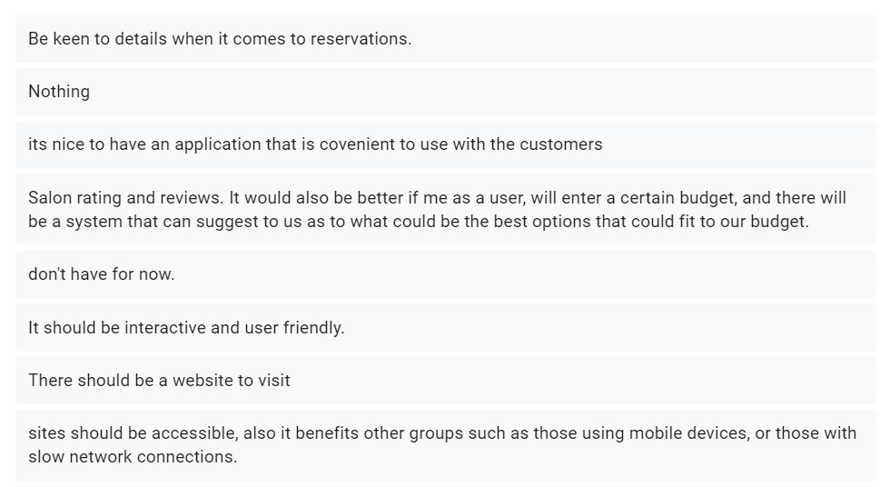

**Salon Owner Survey**

The Salon owner of J4 Beauty Salon and Spa shared a necessary feedback to the questions stated below:

1.What are the challenges your salon is facing?

**Answer:**

Facing difficulty in engaging and retaining clients.Also,having problems in driving sales.But I was not struggling in managing my employees and their appointments.

1. Do you think that having a functionality to book appointments online, access the software through a mobile application, manage clients and their records,market the salon services and the products, manage the employees and send personalized emails and messages to clients can be a good spa and salon software?

**Answer:**

Yes, I think this Software can resolve the challenges that my business had been facing right now since on this pandemic time, we need to conduct a wise way to gain customers.

1. Do you think it is good to have a system like Salon Finder and Salon Booking Management System?

**Answer:**

Yes, I think this can help my business.

1. Do your staff who would normally spend time on the phone talking to customers and scheduling appointments?

**Answer:**

Yes, it consume a lot of time since the customer wants to know some details about the service and they can’t visualize it because it’s via phone call.

1. Do you think it is good idea to have a time table for your staff in various services?If not, then please let us know the reasons.

**Answer:**

No, the time that the services will take matters on what type of hair structure and concerns does the customer had. So, I will not recommend to include a time table on each services on the website.

**Research Design**

This chapter defines the research used methods to enhance the system requirements. Google Forms helps the researchers to conduct the study of Salon Finder and Booking Management System.The researcher explains how the data and information in google forms in order to address the research objectives and questions was collected, presented and analyzed. The researcher wants to know the opinions of the respondents specifically about the functionalities of the system. The data for this particular research was collected using survey and questionnaires by the help of Google Forms.

An online booking system is necessary and required nowadays that is why we would like to point out the benefits of good online booking system that would give us an easy transactions.An online booking system works all the time. This gives freedom to potential customers to book services anytime they want and maximizes sales because the user’s working hours is not limited. In fact studies show that a 24/7 online reservation system greatly increases the number of bookings.It saves a lot of time and effort.

The system should be able to run for all PCs with an operating systems that supports Windows 7 & up-to-date windows and running the Salon App in a single salon environment.  . This is for a single stand-alone PC salon configuration or for a salon with a Local Area Network (LAN) configuration.Internet access allows you to connect to servers and a high speed internet connection is recommended. A single network switch , Wi-Fi with high bandwidth, or router is required if setting up a LAN.

**Description of the Respondents**

A total of 10 friends were the respondents of the study. They are described according to their demographic profile such gender as (male and female) and educational degree (Information Technology, Education, Social Studies).In this study, the accessible population comprised all the Information Technology Students in ACLC College Of Mandaue. Most of them have had technical experience in web development and therefore, they are in the best position to furnish the researcher with the information needed to answer the research question of this study.These survey was created through the use of google form.

These are the respondents (student and guardians) for Pre-Survey.

|  |  |
| --- | --- |
| Timestamp | Email Address |
| 12/8/2020 18:30:08 | catarata.angelica47@gmail.com |
| 12/8/2020 18:30:18 | jmdonnu@gmail.com |
| 12/8/2020 18:37:44 | cesartajanlangit143@gmail.com |
| 12/8/2020 18:48:02 | villarmenterigie@gmail.com |
| 12/8/2020 18:49:36 | Antonjllamado@gmail.com |
| 12/8/2020 19:35:54 | adolfojohnkenneth@gmail.com |
| 12/8/2020 19:47:50 | sarmadikram4@gmail.com |
| 12/8/2020 19:48:57 | subarunakajima64@gmail.com |
| 12/9/2020 8:09:36 | aclc.jadc@gmail.com |
| 12/9/2020 10:46:04 | maria.rovilet233@gmail.com |

*Table 18. Pre- Survey Respondents*

These are the respondents (student and guardians) for Post-Survey.

|  |  |
| --- | --- |
| Timestamp | Email Address |
| 2/13/2021 6:51:02 | subarunakajima64@gmail.com |
| 2/13/2021 8:28:18 | ireneoarcenaljr@gmail.com |
| 2/13/2021 14:09:03 | eizelpanda@gmail.com |
| 2/13/2021 14:34:56 | 123glyndonrosco@gmail.com |
| 2/13/2021 18:12:25 | act.jzka@gmail.com |
| 2/23/2021 11:14:31 | asskicker09876@gmail.com |
| 3/27/2021 14:57:19 | jhenyangbutawan@gmail.com |
| 3/27/2021 15:00:39 | erich_wan@yahoo.com |
| 3/27/2021 15:04:41 | shelamae@shopify.com |
| 3/27/2021 15:06:05 | gemma123@gmail.com |

*Table 19. Post- Survey Respondents*

**Research Instruments**

The researcher designed an interview as one of the data collection of this study. The interview questions were aimed at eliciting relevant information concerning the problems .A questionnaire in Google Forms(see page ____) designed by the researcher titled ”Pre-Survey and Post-Survey Questions for Salon Finder and Booking Management System.” was used in the study. The content of the instrument was based on the findings of the interview conducted with the IT students in ACLC College of Mandaue and the salon owner of J4 Beauty Salon & Spa at 429 Babang II Rd, Cordova, Cebu.These are the instrument of the SFBMS(Salon Finder and Booking Management System):

**COMPONENT**

**Android Phone**

It is a component to be used for mobile application for Salon owners. Customers can use android phones to book the services since the website has been designed to be responsive website. This means that the Salon Finder and Booking Management System can be viewed on any Android phones as long as the device runs a chrome browser.

**Personal Computer**

It is the component to be used for all users to access the full website.

**Wi-Fi**

It is a component to be used to have internet connection.This should be able to support the number of devices you plan to connect in one store.  
 **USER INTERFACE APPLICATION**

* **Mobile Application**

It is an application where the salon owners can access the salon management system.

* **Web page Application**

It is an application where the booking transaction takes place. The users can use the system in 24/7 online through web application platform.

**Hardware Specification**

**Development**

|  |  |
| --- | --- |
| **Hardware Specification for Web/Desktop/Mobile App Development** | |
| **PC** | |
| Processor | Intel Core i5-6500 (2.4 GHz, 3MB L3 Cache) |
| Memory | 4 GB DDR4 Memory |
| Storage | 240 GB M.2 2280 Solid State Drive |
| Display | 14" LCD w/ 1366x768 px resolution |
| Battery | Lithium Ion (Li-Ion) 2800 mAh |
| Communication | WLAN: IEEE 802.11ac / LAN: Gigabit Ethernet |
| **Wi-Fi Router** | |
| Type | Wi-Fi access point, Local Network, Mobile Wifi |
| Wireless Standard | 802.11n, frequency 2.4 / 5 GHz |
| Protection Information | WEP, WPA, WPA2, 802.1x |
| **Mobile Phone** | |
| Processor | MediaTek MT6750 Octa Core |
| Memory | 16GB ROM, 2 GB RAM |
| Display | Touch screen1080x2160 Resolution(5.70) |
| Battery | Non-removable Li-Ion 4130 mAh battery |
| Communication | WLAN: Wi-Fi 802.11 b/g/n, Wi-Fi Direct, hotspot |

*Table 16. Hardware Specification for Web & Mobile App Development*

|  |  |
| --- | --- |
| **Software Specification for Web/Desktop/Mobile App Development** | |
| **PC** | |
| Operating System | Windows 10 |
| Languages | Vue JS, MYSQL , Apache 2 |
| Frameworks, & Libraries | Node.js, Vue-Router, IP Address, WebSocket |
| IDE's & Tools | Visual Studio Code, Notepad |
| Web Browsers | Google Chrome |
|  |  |

*Table 17. Software Specification for Web & Mobile App Development*

**Deployment**

|  |  |
| --- | --- |
| **Hardware Specification for Web/Desktop/Mobile App Development** | |
| **PC** | |
| Processor | Intel Core i5-6500 (2.4 GHz, 3MB L3 Cache) |
| Memory | 4 GB DDR4 Memory |
| Storage | 240 GB M.2 2280 Solid State Drive |
| Display | 14" LCD w/ 1366x768 px resolution |
| Battery | Lithium Ion (Li-Ion) 2800 mAh |
| Communication | WLAN: IEEE 802.11ac / LAN: Gigabit Ethernet |
| **Wi-Fi Router** | |
| Type | Wi-Fi access point, Local Network, Mobile Wifi |
| Wireless Standard | 802.11n, frequency 2.4 / 5 GHz |
| Protection Information | WEP, WPA, WPA2, 802.1x |
| **Mobile Phone** | |
| Processor | MediaTek MT6750 Octa Core |
| Memory | 16GB ROM, 2 GB RAM |
| Display | Touch screen1080x2160 Resolution(5.70) |
| Battery | Non-removable Li-Ion 4130 mAh battery |
| Communication | WLAN: Wi-Fi 802.11 b/g/n, Wi-Fi Direct, hotspot |

*Table 20. Hardware Specification for Paperless Queuing System*

|  |  |
| --- | --- |
| **Hardware Specification for Admin Development** | |
| **PC** | |
| Processor | Intel Core i5-6500 (2.4 GHz, 3MB L3 Cache) |
| Memory | 4 GB DDR4 Memory |
| Storage | 240 GB M.2 2280 Solid State Drive |
| Display | 14" LCD w/ 1366x768 px resolution |
| Battery | Lithium Ion (Li-Ion) 2800 mAh |
| Communication | WLAN: IEEE 802.11ac / LAN: Gigabit Ethernet |
| **Mobile Phone** | |
| Processor | MediaTek MT6750 Octa Core |
| Memory | 16GB ROM, 2 GB RAM |
| Display | Touch screen1080x2160 Resolution(5.70) |
| Battery | Non-removable Li-Ion 4130 mAh battery |
| Communication | WLAN: Wi-Fi 802.11 b/g/n, Wi-Fi Direct, hotspot |

*Table 22. Hardware Specification for Admin Development*

|  |  |
| --- | --- |
| **Software Specification for Admin Development** | |
| **Android Platform** | |
| Operating System | Android 8.0 (Oreo) |
| Software | IP Address Link |
| **Desktop Platform** | |
| Operating System | Windows 10 |
| Software | IP Address Link |
| **Web Platform** | |
| Operating System | Windows 10 |
| Browser | Google Chrome |

*Table 23. Software Specification for Admin Development*

**Data Collection or Data Gathering Procedure**

The survey was conducted by the researcher via Google Forms and Face to Face interview of the Salon Owner. Using Google Forms as a tool for data gathering is a modern methodology of data collection that use of Internet based research. This would mean receiving the respondents response via e-mail on which that would take them to a secure web-site to fill in a questionnaire. This type of research is often quicker and less detailed. Some disadvantages of this method include the exclusion of people who do not have a computer or are unable to access a computer. Along with the Face -to -face interview of the Salon Owner have a distinct advantage, and helps the researcher to establish bond with potential participants and therefore gain cooperation.These interviews yield highest response rates in survey research. They also allow the researcher to clarify answers and when appropriate, seek follow-up information.

**CHAPTER III – RESULTS**

**Data Presentation**

Data presentation is defined as the process of using various graphical formats to visually represent the relationship between two or more data sets so that an informed decision can be made based on them. It gives objectives to the entire development of the Salon Finder and Salon Booking Management System. For data gathering, a questionnaire survey through Google Forms was conducted. The survey comprises of 10 sets of question. The survey was then distributed to 25 respondents for pre-survey purposes and 10 respondents for the post-survey. The respondents are the IT students of ACLC College of Mandaue and Salon lovers. The survey shows the important features that needs to consider in order to build a high standard Salon Booking and Management Software. In Post survey, there 10 respondents who answers the question through the use of google form. The survey comprises of 10 questions. The surveys explain that the result of the systems usability, functionality and feasibility are well integrated to the system.

For the Salon Owners, the researchers use verbal questions for the interview about the system. According to the Salon Owners, the Salon App is very useful and helpful for them, as they said that this will boost their business and avoid crowded people and to implement physical distancing.

The detailed data with corresponding insights from the salon owners and IT students gives so much impact to build the system successfully.

**Data Interpretation**

The Salon App survey gives a wonderful interpretation to assemble the overall functionality of the Salon App. There are many Salon App on the market and it is good to know what we are paying for the services. Will the software boost the Salon business? Does it help to automate all the tasks? The quality of the system matters the most. As we aimed to avoid paperless, crowded, long waiting at Salon and how to boost business online. These are the following main challenges that we need to cope and solved. Salon Booking and Management System is the right place for the Salon Owners who aimed success. Per Survey, the respondents have shared a lot of insights on what they like about Salon App. As a result, the survey was conducted through online and it seems like people wants to have a Salon App that can book and cater all the managerial task, access the salon services into the internet. In general, the Salon Booking and Management System was developed and designed as per the result of the survey.

**Data Analysis**

For Data analysis we use qualitative analysis to assess the development of the system. It includes questions that were stated via google forms and interviews which provides a new perspective on the system’s competitive advantage. Gathering opinions from respondents on the value they see in the Salon App and the services it offered to prospective clients. Often this perception differs from what was assumed. Using google forms to write respondent's feedback about the Salon App and to guide future Salon Businesses, gives a clearer picture of why respondents like the system. Google Forms automate the analysis of the survey. This is the tool that where opinion counts easily since it has automated graphical result and check it by percentage. In this way, the researchers easily analyzed the dominant opinions and suggestions regarding what they experienced and how the app will gonna help those concerns.

**CHAPTER IV – DISCUSSION**

The results of the survey that has been conducted by the researchers makes the project more effective. The aim of the Salon Booking Management System is to automate the Salon transactions. This can allow the users or the customers to set the desired date of appointment with the salon and to record the personal details of customers as well as the transaction details. Convert the manual process of salon management into an online platform with a mobile app support.

**Summary**

Salon Booking Management System is digital solutions, such as online booking and appointment scheduling reduce admin, optimize availability and give ultimate flexibility and convenience to clients. In chapter 1, it explains the advantages of having the Salon Finder and management Booking System. That the system integrate an instant online booking directly to the salon's results page on Google Search or Google Maps. Its main goal is to Stop missing out on potential customer

In chapter 2, the researchers needed a method to support and analyze the data. These are the pre-survey, post survey, personal questions to the staff about the salon system that some salon businesses doesn’t have. The costing of the system, the hardware and software specification, the respondent survey and result. The researchers needed this method to gather specific data and alignment to the system. The integration and functionality of the system is a must, these are combine quantitative and qualitative materials to develop the system. The method help the researchers to surpass the misconception of the system. These will prove that methods are the way to provide the main purpose of the study due to the respondent who are being true by answering the questions given by the researchers.

In chapter 3, which is the result of the chapter 2 methods in which the progress of the chapter 2 answers the result in chapter 3. The graph will show how useful and innovative the paperless queuing system is. The results gather from the chapter 3 is fact and justified by the chapter 2.

In a way that the result will prove how the system is develop slowly and mold by the respondent response. And also the staff of the school helps a lot to cooperate the said matter. These are the evidence that the researchers will hold and apply these sooner.

In chapter 4, the summary of all the chapters from 1 to 4 is applied. The recommendations and conclude for the users, staffs, administrator, researcher’s and future researchers that will deploy the system is the way of data gathering to support the project. The researcher’s data is reliable to make this project achieved successfully. The project was well tested by the researcher. It was tested using automation tool for fast an reliable bug results. The project is designed for mobile and web platform. It could be a game changer to any salon businesses.

**Conclusion**

The researcher conclude that this type of Salon booking and management system can maximize reservations and faster way of transaction. This is helpful for any kind of queue transaction for a better solution. Online booking means you capture more potential business because reservations and information are always available.The development of system will be using the INTRODUCTION METHOD RESULT AND DISCUSSION (IMRAD) method. By evaluating the process of Salon booking and management system, this system could help promote the loyal customers to pre-book their next appointment for when the salon business plan to be open again  due to COVID-19. This system helps salon staff to check the wait list of the customer. A wait list can give you a sense of just how many clients are eager to return, when, and for which services. You can also get a sense of which staff members are in highest demand to start building your schedule. This is especially helpful as you may need to have your team work in shifts.

The GUI of this system is so responsive and attractive design. The design of the system creates awesome impressions and attracts more visitors.

**Recommendation**

Everything can be customize to the brand look and feel. This project will be first implemented to the selected salon shop located in Cordova, Cebu, Philippines.

The salon owners who wants to request will be having all default features and free to request a functionality that the system not covered yet. Any recommendation about the system will be highly appreciated as the researcher aimed to get the best salon solutions.

**References**

**Web Resources**

**Docs, Guides, and Codes**

* https://forms.gle/j6RMEzBJyYjrRnSaA
* https://www.raspberrypi.org/downloads/raspberry-pi-os/
* https://www.raspberrypi.org/documentation/raspbian/applications/omxplayer.md
* https://www.php.net/manual/en/book.ds.php
* https://www.php.net/manual/en/function.msg-set-queue.php
* https://q4m.github.io/
* https://www.npmjs.com/package/student-queue-mariadb-plugin
* https://whstatic.1and1.com/help/CloudServer/EN-US/d849943.html
* https://onlinerandomtools.com/generate-random-ip
* https://generate.plus/en/address/ip
* https://www.slideshare.net/mobile/Nab287/queue-38646798
* https://www.slideshare.net/mobile/RojanPariyar/presentation-on-queue
* https://learn.jquery.com/effects/queue-and-dequeue-explained/
* https://stackoverflow.com/questions/1058158/what-are-queues-in-jquery

**Appendices**

**Pre-Implementation Survey**

When a salon is closed, do you prefer to book online? *

Yes

No

Maybe

Before making a booking, Do you like to check the services offered directly on the website?

Yes

No

Maybe

Do you want to see first the upcoming deals and promotions before choosing a booking date? *

Yes

No

Maybe

Is it helpful for you to display on the website, the reviews & testimonials, before and after pictures of past work before choosing a salon?

Yes

No

Maybe

Is it helpful for you to include a detailed description of treatments & services displayed on the website?

Yes

No

Maybe

Do you also want to know the information on products used or for sale at the salon?

Yes

No

Maybe

Do you like to check other salons on the same website after checking one salon you visited online?

Yes

No

Maybe

Which of these two features are most important to you on the salon/barber/spa website?

Products for sale online

Blog and news on the latest trends

This software can help to search available Salons and get directions via Google Map. Do you like the concept of the Software? *

Yes

No

Maybe

Is it helpful for you to use a website that can find the nearest salon and display the location and prominently displayed the salon opening hours? *

Yes

No

Maybe

**Post-Implementation Survey**

How often do you at least go to the salon? *

once a week

once a month

Once every three months

On special occasions

Other:



Do you make reservations before going to the salon?

Yes

No

What are the most common problems that you face when you go to the salon? *

Congestion and long wait

Salon prices

Problems with an employee

Problems when you book in advance

Other:



What are the factors that greatly affect your decision when choosing a beauty Salon? *

not important

important

very important

price

The location and location of the salon

Salon Popularity

Quality of services

Friends Recommendation

Special offers

price

The location and location of the salon

Salon Popularity

Quality of services

Friends Recommendation

Special offers

What are the ways that you go to search for a beauty salon? *

Searching the Internet using search engines

through friends

Ads

newspapers and magazines

Social Media

Other:



Do you prefer to book appointments through the mobile application? *

Yes

No

Maybe

Do you want to know all the salons around you and near you and know the services you provide and learn about others' experience? *

Yes

No

Maybe

What OS do you prefer for the application? *

Android

IOS iPhone

Windows Phone

Other:



Do you have any suggestions on our project? *

**Main Page Codes**

**Index.php**

<!DOCTYPE html>

<html lang="en">

<head>

<meta charset="utf-8">

<link href="CSS/index.css" rel="stylesheet">

<meta name="viewport" content="width=device-width, initial-scale=1.0">

<script src="JS/mainjs.js"></script>

</head>

<title>aclc queuing system</title>

<body>

<script src="JS/indexjs.js"></script>

<div class="container">

<div class="button_containers">

<button id="gpn">Get Priority Number</button>

<button id="cl">CASHIER AND ADMIN Log-In</button>

<button id="cne">PRIORITY Number Entertained </button>

</div>

</div>

</body>

</html>

**cashiersys.php**

<?php

//THIS IS THE MAIN FILE OF THE CASHIER SYSTEM AND THE PAGE OF CASHIER SYSTEM

//THIS FUNC IS TO REPLACE THE STRING CONTENT

function replace_string_in_file($filename, $string_to_replace, $replace_with){